# Path finding Visualizer

## Setting up a skeleton project

## Getting started

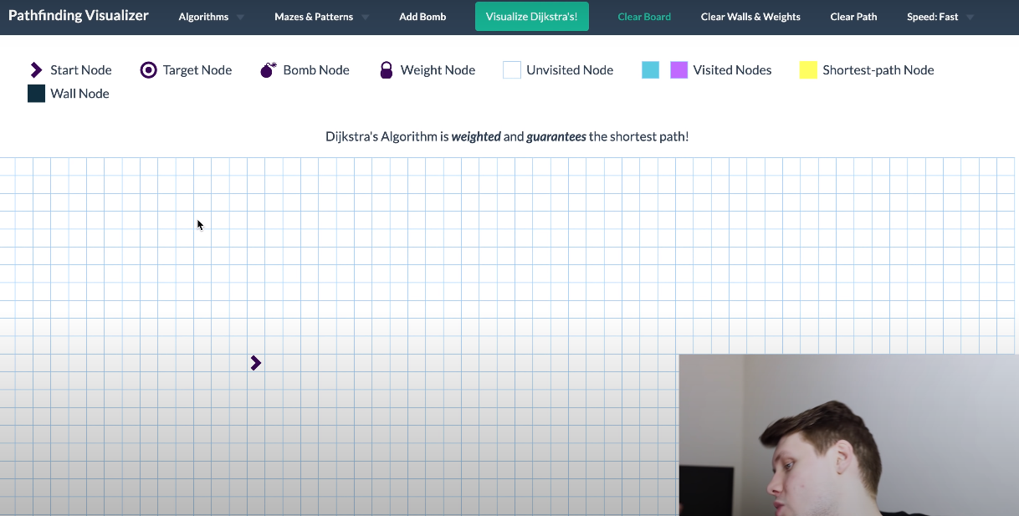

So, the initial thing is to setup the grid over which the whole pathfinding visualization happens.

### Creating a grid

1. Created node element will be a like a box with css
   1. Width, height and border
2. So, we shall create an array with arrays in it (for columns)
   1. Iterate over an array and push array elements in it.
3. And push the above nodes in to it.
   1. Through array.map(<Node></Node>)